ASTA TRIPLE SCREEN SETUP
Detailed Mockup + Pivot Table Specification
Prepared from the provided one-page setup checklist

SCOPE | This document preserves the rules, wording, conditions, supporting indicators, stop-loss rules and target rules shown in the provided setup. Proposed dashboard/status mockups are clearly marked as design suggestions and are not presented as source rules.

CORE IDEA | Three-screen logic: Tide establishes the larger trend, Wave is the retracement against Tide, and Ripple provides the entry-side pattern/candlestick/indicator conditions.

Contents
1. Setup Architecture
2. BUY Setup – Source Rules
3. SELL Setup – Source Rules
4. Supporting Indicators
5. Stop Loss & Target Rules
6. Pivot Table – Complete Setup Comparison
7. Proposed Setup State Flow
8. Proposed Dashboard Mockups
9. Proposed Chart Label Mockups
10. Coding-Ready Decision Logic
11. Source Terms / Abbreviations Not Expanded in PDF
12. Original Source Snapshot
13. Visual Snapshot Mockups

1. Setup Architecture
Screen | Role in Setup | BUY Context | SELL Context
Tide | Defines the main trend / larger market direction | Uptrend: higher highs and higher lows OR TI Uptick / Flat after Down | Downtrend: lower highs and lower lows OR TI Downtick / Flat after Up
Wave | Retracement against the Tide direction | Retracement against Tide uptrend; source specifies HL | Retracement against Tide downtrend; source specifies LH
Ripple | Entry-side confirmation layer | Bullish reversal/continuation pattern + bullish candlestick + BB/EMA/RSI/Stochastic/Fib conditions | Bearish reversal/continuation pattern + bearish candlestick + BB/EMA/RSI/Stochastic/Fib conditions

Source: user-provided “ASTA Triple Screen Setup” checklist PDF.
SOURCE PHILOSOPHY | The checklist says: “The more conditions satisfy, better the probability.” The signal column separately marks a Mandatory Conditions block, individual Buy/Sell conditions, and “Better” confirmations.

2. BUY Setup – Source Rules

2.1 BUY Mandatory Conditions
No. | Screen | Condition | Source Signal
B1 | Tide | Price in Uptrend (making higher highs and higher lows) OR | Buy – Mandatory Conditions
B2 | Tide | TI Uptick or Flat after Down AND | Buy – Mandatory Conditions
B3 | Wave | Price doing a Retracement against Uptrend in Tide (HL) AND | Buy – Mandatory Conditions
B4 | Pattern | Bullish Chart Patterns: DB with BKP, FBD of Support, Inv. H&S, C&H, F&P | Buy – Mandatory Conditions
B5 | Ripple | Chart Pattern – Bullish Reversal OR Bullish Continuation AND | Buy – Mandatory Conditions
B6 | Ripple | Bullish Candlestick | Buy – Mandatory Conditions

Source: user-provided “ASTA Triple Screen Setup” checklist PDF.

2.2 Additional BUY Conditions
No. | Ripple / Market Condition | Signal in Source | Interpretation for Mockup
B7 | Lower BB – BKP or BBUC | Buy | Additional directional BUY condition
B8 | 5 EMA Crossing above 13 EMA or 26 EMA in last 3 periods (N/A for DB/MS) | Buy | Additional directional BUY condition
B9 | RSI > 40 (Best when Crossing Above 60) | Buy | Additional directional BUY condition
B10 | Stochastic PCO (better from Oversold level) | Buy | Additional directional BUY condition
B11 | Fib < 61.8% of last Wave | Buy | Additional directional BUY condition
B12 | Futures – Long Buildup AND ATM PE – TMJ | Better | Strength / quality confirmation

Source: user-provided “ASTA Triple Screen Setup” checklist PDF.
BUY FLOW – SOURCE-BASED | Tide bullish context → Wave retracement against Tide (HL) → bullish chart pattern → Ripple bullish reversal/continuation + bullish candlestick → additional Ripple conditions → supporting “Better” confirmations.

3. SELL Setup – Source Rules

3.1 SELL Mandatory Conditions
No. | Screen | Condition | Source Signal
S1 | Tide | Price in Downtrend (making lower highs and lower lows) OR | Sell – Mandatory Conditions
S2 | Tide | TI Downtick or Flat after Up AND | Sell – Mandatory Conditions
S3 | Wave | Price doing a Retracement against Downtrend in Tide (LH) AND | Sell – Mandatory Conditions
S4 | Pattern | Bearish Chart Patterns: DT with BKT, FBO of Resistance, H&S, Rounding Top, F&P | Sell – Mandatory Conditions
S5 | Ripple | Chart Pattern – Bearish Reversal OR Bearish Continuation AND | Sell – Mandatory Conditions
S6 | Ripple | Bearish Candlestick | Sell – Mandatory Conditions

Source: user-provided “ASTA Triple Screen Setup” checklist PDF.

3.2 Additional SELL Conditions
No. | Ripple / Market Condition | Signal in Source | Interpretation for Mockup
S7 | Upper BB – BKT or BBDC | Sell | Additional directional SELL condition
S8 | 5 EMA Crossing below 13 EMA or 26 EMA in last 3 periods (N/A for DT/ES) | Sell | Additional directional SELL condition
S9 | RSI < 60 (Best when crossing below 40) | Sell | Additional directional SELL condition
S10 | Stochastic NCO (better from Overbought level) | Sell | Additional directional SELL condition
S11 | Fib < 61.8% of last Wave | Sell | Additional directional SELL condition
S12 | Futures – Short Buildup AND ATM CE – TMJ | Better | Strength / quality confirmation

Source: user-provided “ASTA Triple Screen Setup” checklist PDF.
SELL FLOW – SOURCE-BASED | Tide bearish context → Wave retracement against Tide (LH) → bearish chart pattern → Ripple bearish reversal/continuation + bearish candlestick → additional Ripple conditions → supporting “Better” confirmations.

4. Supporting Indicators
Supporting Module | Condition | Source Result | How to Display in Mockup
Divergence – Regular or Reverse (Stochastic and/or RSI) | In the direction of Trade (e.g. Bullish Divergence for Long Entry & vice versa) | Go for it!!! | Strong positive confirmation
Divergence – Regular or Reverse (Stochastic and/or RSI) | In the opposite direction of Trade (e.g. Bullish Divergence for Short Entry) | Watchful | Caution / conflict
Volume | Above average Volume for Candle Challenging Bollinger Band / Chart Pattern Confirmation Candle | Better | Quality confirmation
Options OI – DB / DT | ATM PE / CE – TMJ | Better | Quality confirmation
Continuation Pattern – Bullish / Bearish | ITM and ATM CE / PE – TMG; ATM PE / CE TMJ | Better | Quality confirmation

Source: user-provided “ASTA Triple Screen Setup” checklist PDF.

5. Stop Loss & Target Rules
Trade | Stop Loss Rule
Long Trade | Below Reversal or Continuation Chart Pattern Confirmation Candle
Short Trade | Above Reversal or Continuation Chart Pattern Confirmation Candle

Target Basis | Source Rule
Major Support / Resistance | Calculate target based on Major Support / Resistance
Fibonacci | Use Fibonacci Retracement or Extension

Source: user-provided “ASTA Triple Screen Setup” checklist PDF.
IMPORTANT | The source does not provide a fixed numeric Risk:Reward ratio, a fixed number of targets, or a fixed entry-price formula for this Triple Screen checklist. Do not invent these without a separate rule source.

6. Pivot Table – Complete BUY vs SELL Comparison
Module | BUY | SELL | Source Class
Tide Structure | Uptrend – HH/HL OR TI Uptick / Flat after Down | Downtrend – LH/LL OR TI Downtick / Flat after Up | Mandatory block
Wave Structure | Retracement against uptrend in Tide (HL) | Retracement against downtrend in Tide (LH) | Mandatory block
Chart Pattern | DB with BKP, FBD of Support, Inv. H&S, C&H, F&P | DT with BKT, FBO of Resistance, H&S, Rounding Top, F&P | Mandatory block
Ripple Pattern | Bullish Reversal or Bullish Continuation | Bearish Reversal or Bearish Continuation | Mandatory block
Ripple Candlestick | Bullish Candlestick | Bearish Candlestick | Mandatory block
Bollinger Band | Lower BB – BKP or BBUC | Upper BB – BKT or BBDC | Buy/Sell
EMA | 5 EMA crosses above 13/26 EMA in last 3 periods (N/A for DB/MS) | 5 EMA crosses below 13/26 EMA in last 3 periods (N/A for DT/ES) | Buy/Sell
RSI | >40; best crossing above 60 | <60; best crossing below 40 | Buy/Sell
Stochastic | PCO; better from Oversold | NCO; better from Overbought | Buy/Sell
Fib | <61.8% of last Wave | <61.8% of last Wave | Buy/Sell
Futures | Long Buildup AND ATM PE – TMJ | Short Buildup AND ATM CE – TMJ | Better
SL | Below reversal/continuation confirmation candle | Above reversal/continuation confirmation candle | Stop loss
Target | Major S/R or Fibonacci Retracement / Extension | Major S/R or Fibonacci Retracement / Extension | Target

Source: user-provided “ASTA Triple Screen Setup” checklist PDF.

7. Proposed Setup State Flow
DESIGN NOTE | The statuses below are a proposed mockup for software/dashboard presentation. They are not stated in the PDF.

Proposed Status | Meaning | Suggested Trigger
NO SETUP | No valid Tide / Wave directional context | Tide and/or Wave mandatory context absent
FORMING | Tide + Wave context exists, but Ripple mandatory confirmation is incomplete | Mandatory block partially complete
READY | Mandatory source block is complete | B1-B6 or S1-S6 complete
CONFIRMED BUY / SELL | Ready + selected additional directional conditions complete | User/developer can define exact minimum count if desired
HIGH QUALITY | Confirmed + one or more “Better” source conditions align | Volume / Futures / Options / continuation confirmations
WATCHFUL | Opposite-direction divergence is present | Source divergence row says “Watchful”
INVALID / RESET | Mandatory directional context no longer valid before trade | Proposed reset logic; exact invalidation rules require separate definition

8. Proposed Dashboard Mockups
DESIGN NOTE | These are display mockups only. They do not add new trading rules.

8.1 BUY – FORMING Mockup
Dashboard Row | Mockup Value
SETUP | TRIPLE SCREEN
DIRECTION | BUY
TIDE | UPTREND / HH-HL
WAVE | RETRACEMENT – HL
MANDATORY | 4 / 6 COMPLETE
RIPPLE | WAIT BULLISH PATTERN + CANDLE
BB | WAIT BKP / BBUC
EMA | WAIT
RSI | >40 ✓
STOCHASTIC | WAIT PCO
FIB | <61.8% ✓
SUPPORT | VOLUME / DIVERGENCE / OI
STATUS | FORMING
ACTION | WAIT

8.2 BUY – CONFIRMED Mockup
Dashboard Row | Mockup Value
SETUP | TRIPLE SCREEN
DIRECTION | BUY
TIDE | UPTREND / HH-HL
WAVE | HL RETRACEMENT
MANDATORY | 6 / 6 COMPLETE
PATTERN | BULLISH REVERSAL / CONTINUATION
CANDLE | BULLISH
BB | BKP / BBUC ✓
EMA | 5 > 13/26 CROSS ✓
RSI | >40 ✓ | >60 = STRONGER
STOCHASTIC | PCO ✓
FIB | <61.8% ✓
BETTER | VOLUME / FUTURES / OPTIONS if aligned
SL | BELOW CONFIRMATION CANDLE
TARGET | MAJOR S/R OR FIB
STATUS | CONFIRMED BUY

8.3 SELL – CONFIRMED Mockup
Dashboard Row | Mockup Value
SETUP | TRIPLE SCREEN
DIRECTION | SELL
TIDE | DOWNTREND / LH-LL
WAVE | LH RETRACEMENT
MANDATORY | 6 / 6 COMPLETE
PATTERN | BEARISH REVERSAL / CONTINUATION
CANDLE | BEARISH
BB | BKT / BBDC ✓
EMA | 5 < 13/26 CROSS ✓
RSI | <60 ✓ | <40 = STRONGER
STOCHASTIC | NCO ✓
FIB | <61.8% ✓
BETTER | VOLUME / FUTURES / OPTIONS if aligned
SL | ABOVE CONFIRMATION CANDLE
TARGET | MAJOR S/R OR FIB
STATUS | CONFIRMED SELL

9. Proposed Chart Label Mockups
DESIGN NOTE | Labels below are proposed visual wording only.

Situation | Suggested Chart Text | What It Means
BUY mandatory block incomplete | TS BUY – FORMING | Tide/Wave context present; waiting Ripple / remaining conditions
BUY mandatory block complete | TS BUY – READY | Source mandatory block complete
BUY confirmed by chosen implementation threshold | TRIPLE SCREEN BUY | Trade-side setup confirmed by implementation rules
SELL mandatory block incomplete | TS SELL – FORMING | Tide/Wave context present; waiting Ripple / remaining conditions
SELL mandatory block complete | TS SELL – READY | Source mandatory block complete
SELL confirmed by chosen implementation threshold | TRIPLE SCREEN SELL | Trade-side setup confirmed by implementation rules
Opposite divergence | WATCHFUL | Source says opposite-direction divergence = Watchful
Aligned divergence | GO FOR IT | Source says divergence in trade direction = Go for it!!!

10. Coding-Ready Decision Logic
IMPORTANT | This section converts the checklist into software-friendly groups without changing the source conditions. The exact threshold for how many additional Buy/Sell conditions must be true is not specified in the PDF.

10.1 BUY Boolean Groups
Group | Conditions
BUY Mandatory Group | (Tide Uptrend HH/HL OR TI Uptick/Flat after Down) AND Wave HL retracement AND one listed bullish chart pattern AND Ripple bullish reversal/continuation AND Ripple bullish candlestick
BUY Additional Group | Lower BB BKP/BBUC; EMA cross above; RSI >40; Stoch PCO; Fib <61.8%
BUY Better Group | Futures Long Buildup + ATM PE-TMJ; aligned divergence; above-average volume; Options OI / continuation conditions marked Better
BUY SL | Below reversal/continuation chart-pattern confirmation candle
BUY Target | Major S/R or Fibonacci Retracement/Extension

10.2 SELL Boolean Groups
Group | Conditions
SELL Mandatory Group | (Tide Downtrend LH/LL OR TI Downtick/Flat after Up) AND Wave LH retracement AND one listed bearish chart pattern AND Ripple bearish reversal/continuation AND Ripple bearish candlestick
SELL Additional Group | Upper BB BKT/BBDC; EMA cross below; RSI <60; Stoch NCO; Fib <61.8%
SELL Better Group | Futures Short Buildup + ATM CE-TMJ; aligned divergence; above-average volume; Options OI / continuation conditions marked Better
SELL SL | Above reversal/continuation chart-pattern confirmation candle
SELL Target | Major S/R or Fibonacci Retracement/Extension

11. Source Terms / Abbreviations Not Expanded in PDF
Term | How It Appears | Handling in This Mockup
TI | TI Uptick / TI Downtick | Kept exactly as source; PDF does not expand the term
F&P | Listed among bullish/bearish chart patterns | Kept exactly as source
TMJ | Used with ATM PE / CE and Options OI / Futures rows | Kept exactly as source
TMG | Used in Continuation Pattern row | Kept exactly as source
DB/MS | EMA condition says N/A for DB/MS | Kept exactly as source; no expansion added
DT/ES | EMA condition says N/A for DT/ES | Kept exactly as source; no expansion added
BBUC / BBDC | Used as alternatives to BKP/BKT on Ripple | Kept exactly as source

WHY THIS MATTERS | Because the one-page source does not define these abbreviations, this document intentionally does not guess their exact expansion or logic. They should be locked from a separate official note before coding.

12. Original Source Snapshot
Provided ASTA Triple Screen Setup checklist (1 page).
Source: user-provided “ASTA Triple Screen Setup” checklist PDF.
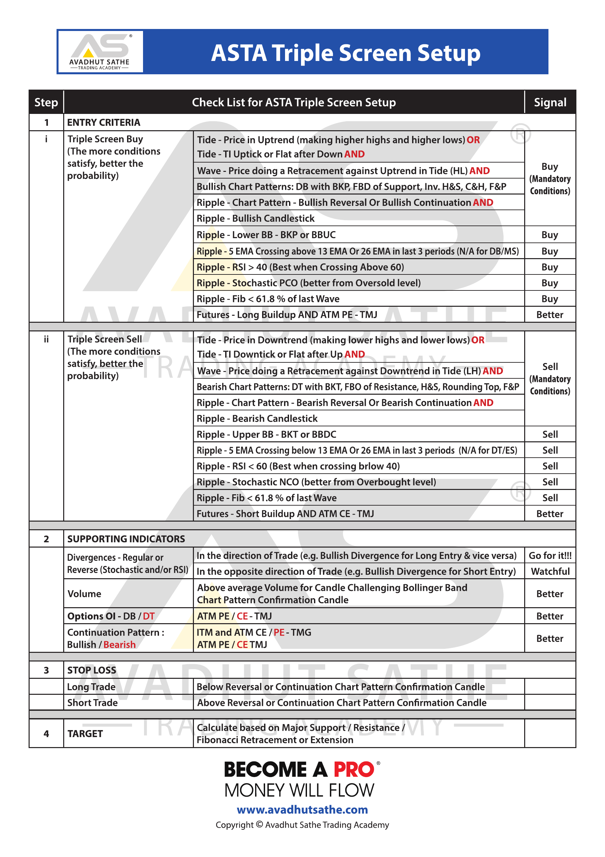

13. Visual Snapshot Mockups
Purpose: These snapshots convert the written checklist into visual examples so that a developer, trader, or reviewer can understand the setup even if the wording is unfamiliar. They are explanatory mockups, not live-market screenshots and not extra trading rules.

13.1 Triple Screen Architecture Snapshot
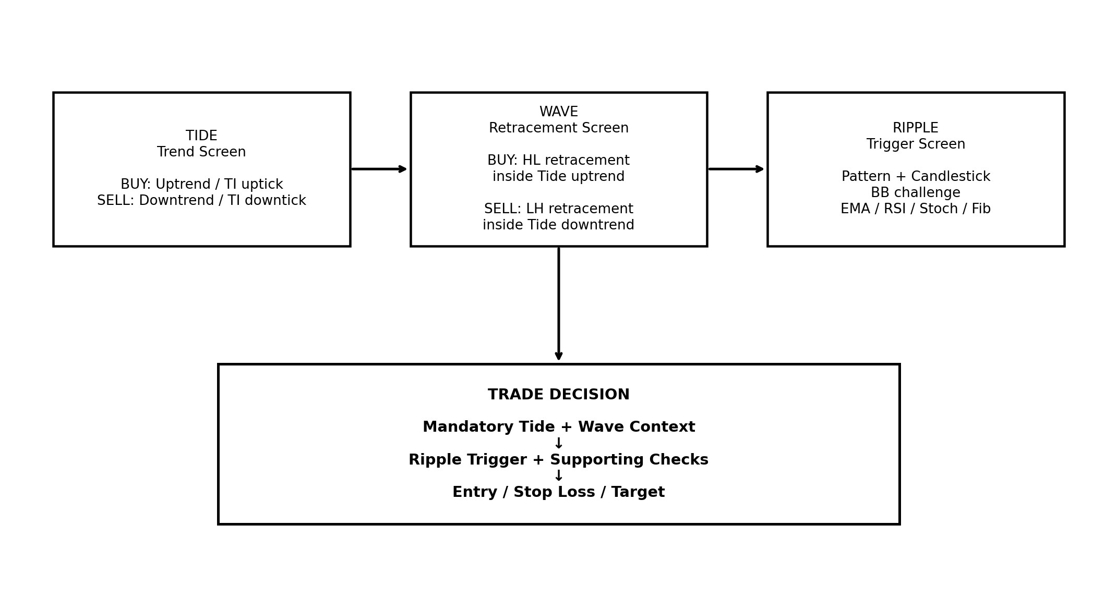
Figure 13.1 — Tide establishes context, Wave shows the retracement, and Ripple supplies the trade trigger.

13.2 BUY Setup Snapshot
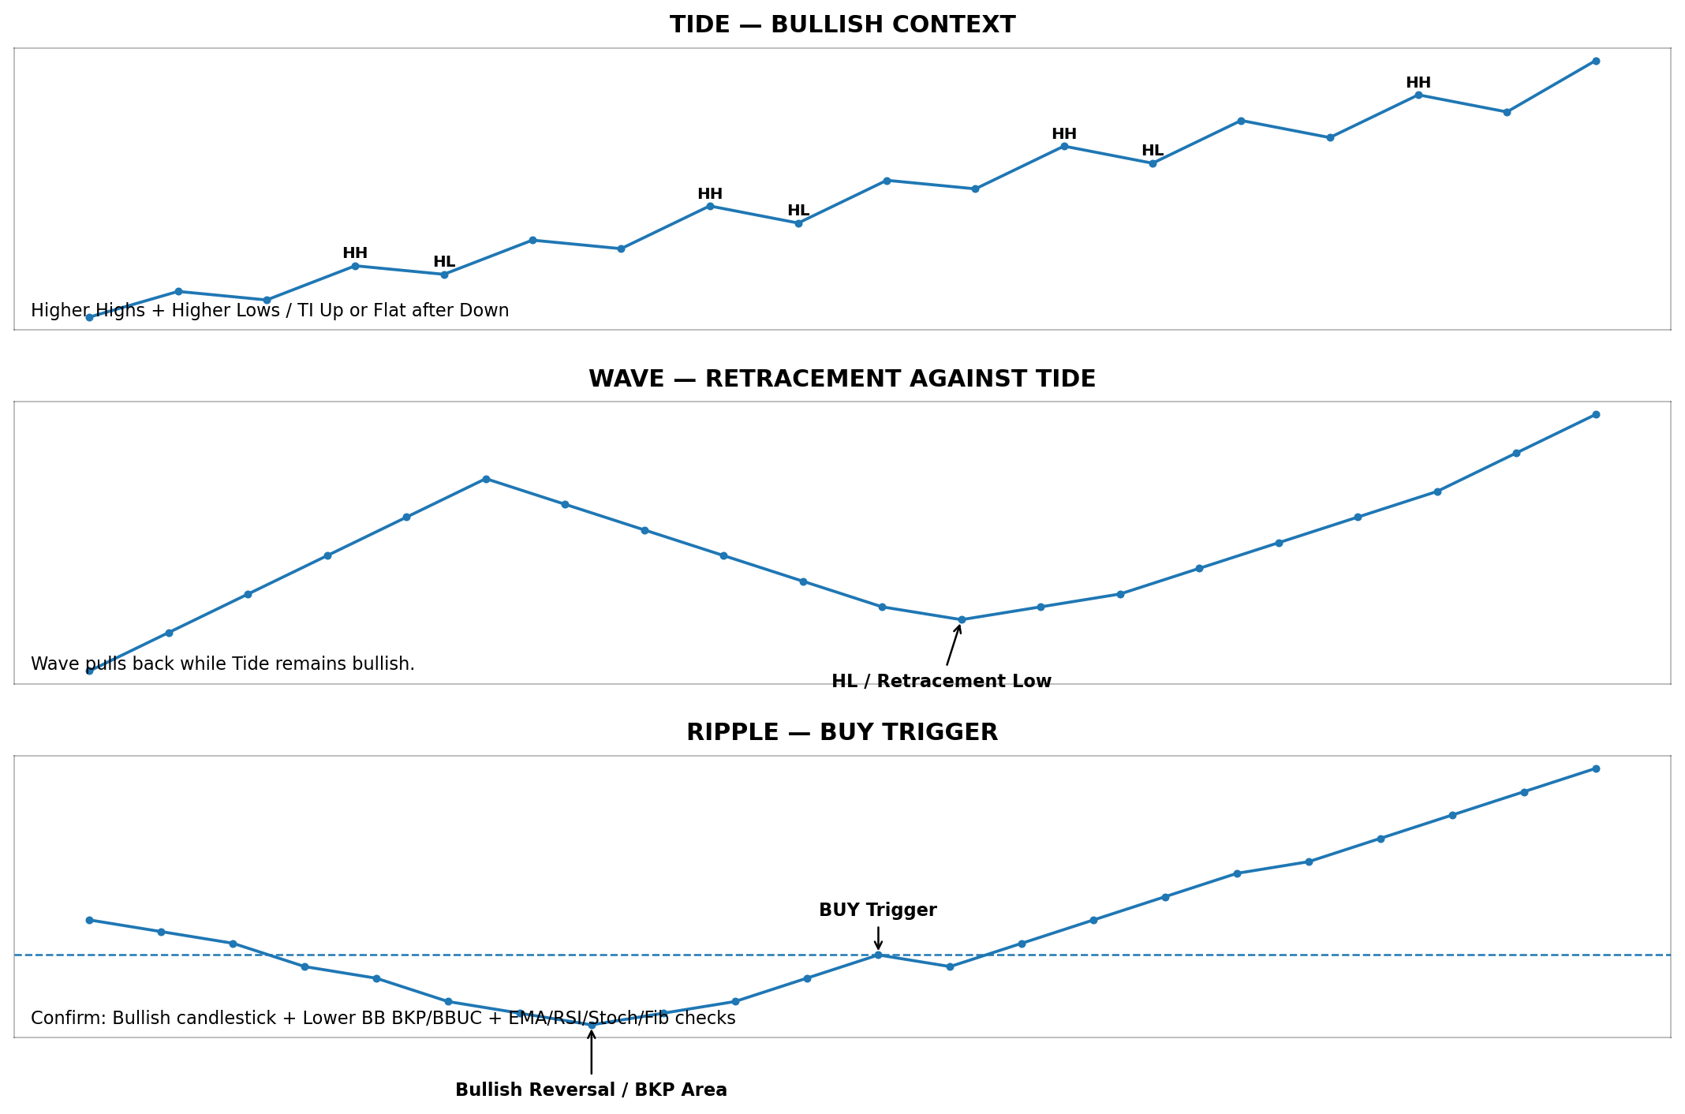
Figure 13.2 — Bullish example: Tide remains in an uptrend, Wave forms a retracement/Higher Low, and Ripple produces the bullish reversal/trigger.

13.3 SELL Setup Snapshot
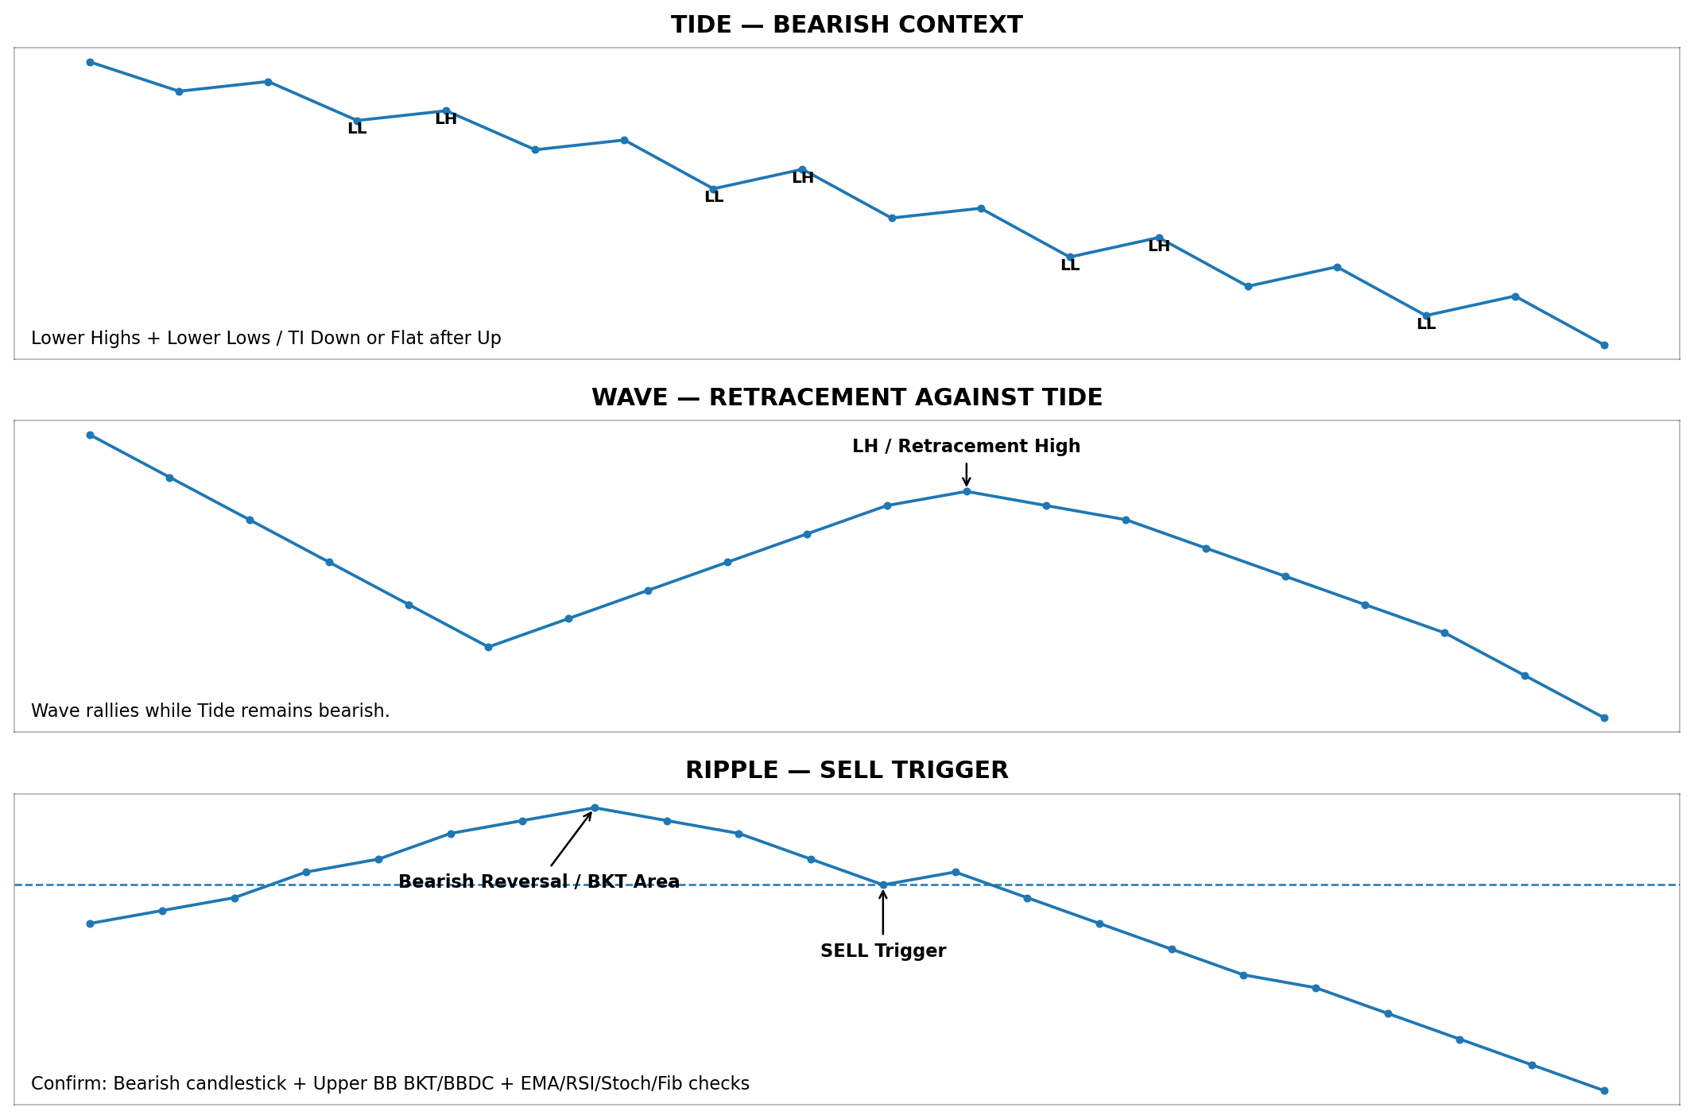
Figure 13.3 — Bearish example: Tide remains in a downtrend, Wave forms a retracement/Lower High, and Ripple produces the bearish reversal/trigger.

13.4 Dashboard Snapshot — BUY Confirmed Example
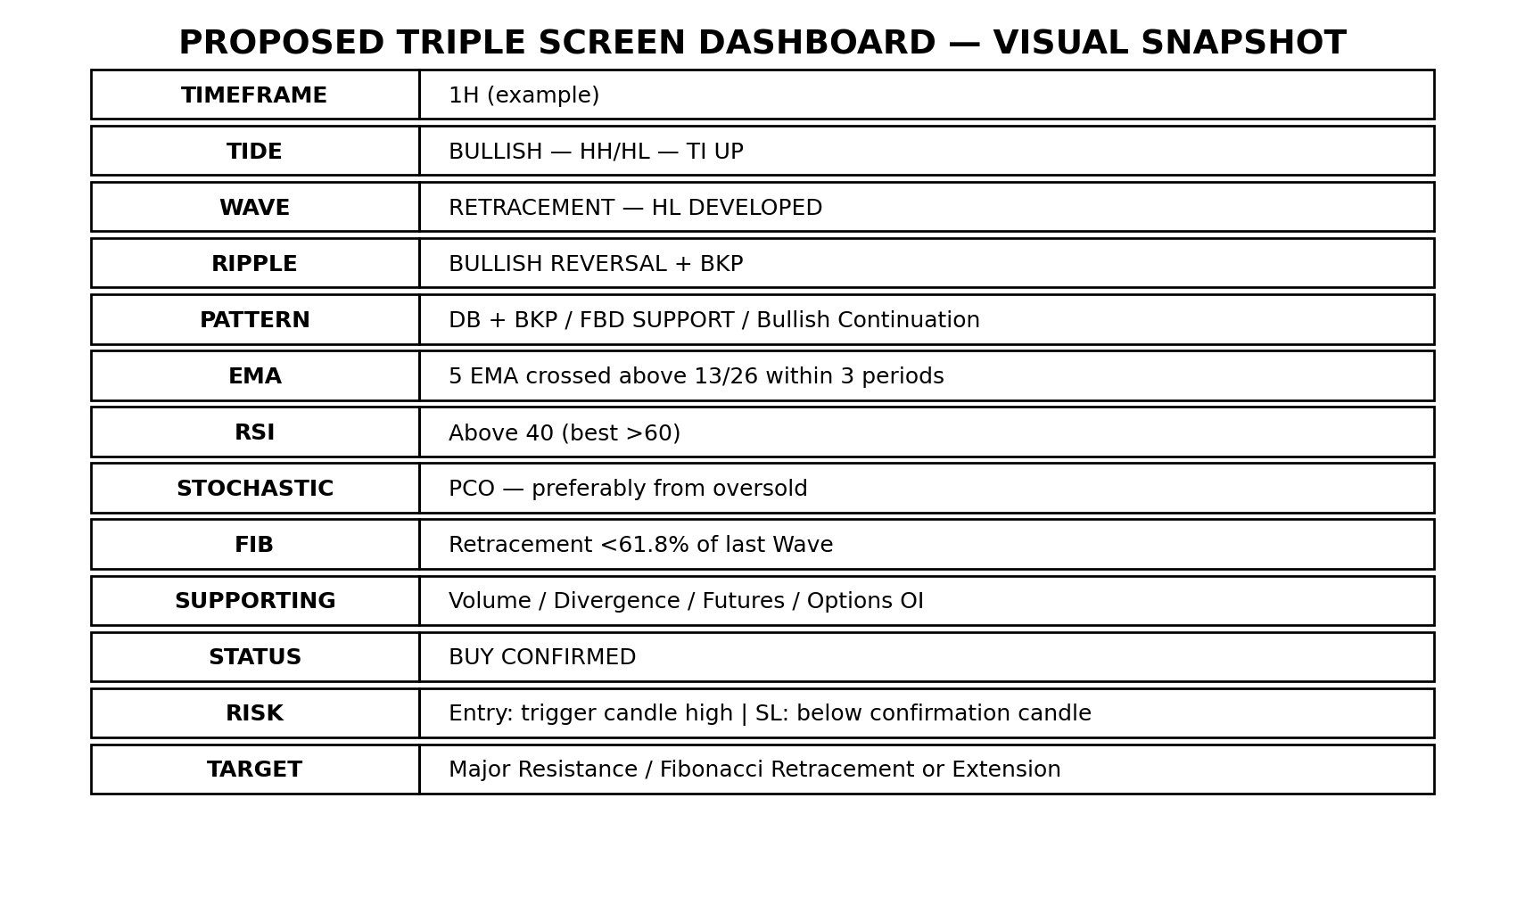
Figure 13.4 — Proposed dashboard presentation. It visually groups Tide, Wave, Ripple, pattern, confirmations, trade status, risk and target.

13.5 Chart Trade-Plan Snapshot
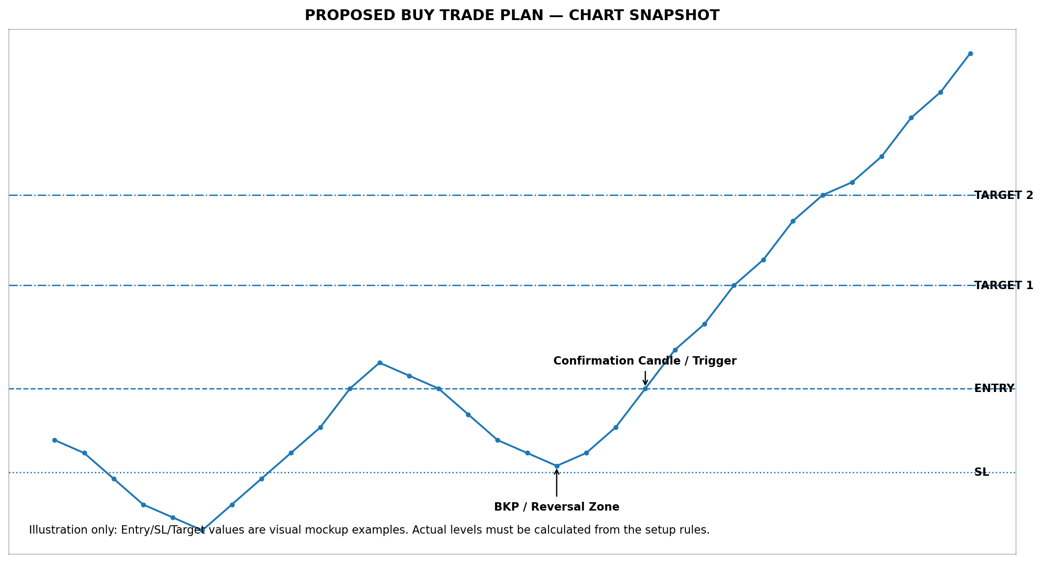
Figure 13.5 — Proposed chart presentation showing the trigger zone, entry, stop loss and targets. Prices shown are illustrative only.

13.6 How to Read the Visual Mockups
Visual Step | What the Reader Should Understand
Step 1 — Tide | First decide whether the higher screen is bullish or bearish according to the source conditions.
Step 2 — Wave | Then identify the retracement against the Tide: Higher Low context for BUY or Lower High context for SELL.
Step 3 — Ripple | Wait for the reversal/continuation pattern, candlestick and Bollinger Band trigger on Ripple.
Step 4 — Additional Checks | Review EMA cross, RSI, Stochastic, Fibonacci and the supporting indicators shown in the source checklist.
Step 5 — Trade Plan | After confirmation, derive Entry, Stop Loss and Target from the source rules. The mockup lines are examples, not substituted rules.
Source-control note: The written setup rules remain the authority. These snapshots are only visual interpretations of the one-page ASTA Triple Screen checklist and do not add missing definitions for abbreviations such as TI, BKP/BKT, BBUC/BBDC, TMJ/TMG, H&S, C&H or F&P.

